Exp 9 (version 2)- Model Deployment Using Flask REST API and Docker

Aim
To train a machine learning model, deploy it using a Flask REST API, visualize the results, and prepare the application for Docker containerization.

Procedure
- Import the required Python libraries and load the Iris dataset.
- Split the dataset into training and testing sets.
- Train a Random Forest classification model and save it using Joblib.
- Create a Flask REST API to accept input features and return predictions in JSON format.
- Test the API and display the prediction output.
- Visualize the dataset, confusion matrix, and prediction probabilities using Matplotlib.
- Create a Dockerfile and requirements file for containerization.
- Display the results and verify that the deployment files are created successfully.

Code

!pip install flask scikit-learn joblib requests matplotlib -q

import os, socket, threading, time, joblib, requests import matplotlib.pyplot as plt
from sklearn.datasets import load_iris
from sklearn.model_selection import train_test_split from sklearn.ensemble import RandomForestClassifier
from sklearn.metrics import confusion_matrix, ConfusionMatrixDisplay from flask import Flask, request, jsonify
from werkzeug.serving import make_server

iris = load_iris()
X, y = iris.data, iris.target

X_train, X_test, y_train, y_test = train_test_split( X, y, test_size=0.2, random_state=42
)

model = RandomForestClassifier(random_state=42) model.fit(X_train, y_train)
joblib.dump(model, "model.pkl")

print("Model trained successfully!")
print("Accuracy:", round(model.score(X_test, y_test) * 100, 2), "%")

app = Flask( name )
classes = iris.target_names.tolist()

@app.route("/") def home():
return jsonify({"message": "ML Model API is running"})

@app.route("/predict", methods=["POST"]) def predict():
try:
features = request.get_json()["features"]

if len(features) != 4:
return jsonify({"error": "Enter 4 features"}), 400 prediction = int(model.predict([features])[0]) return jsonify({
"prediction": classes[prediction], "class_id": prediction,
"probabilities": model.predict_proba([features])[0].tolist()
})
except Exception as e:
return jsonify({"error": str(e)}), 400

sock = socket.socket() sock.bind(("127.0.0.1", 0)) port = sock.getsockname()[1] sock.close()

server = make_server("127.0.0.1", port, app)
thread = threading.Thread(target=server.serve_forever, daemon=True) thread.start()
time.sleep(1)

url = f"http://127.0.0.1:{port}"
print("\nAPI Response:", requests.get(url).json())

sample = [5.1, 3.5, 1.4, 0.2]
response = requests.post(url + "/predict", json={"features": sample})

result = response.json()

print("\nInput:", sample) print("Prediction:", result["prediction"])
print("Status Code:", response.status_code)

plt.figure(figsize=(7, 4))
plt.scatter(X_test[:, 0], X_test[:, 1], c=y_test, cmap="viridis") plt.xlabel("Sepal Length")
plt.ylabel("Sepal Width") plt.title("Iris Dataset Visualization") plt.show()

y_pred = model.predict(X_test) ConfusionMatrixDisplay(
confusion_matrix(y_test, y_pred), display_labels=classes
).plot(cmap="Blues") plt.title("Confusion Matrix") plt.show()

plt.figure(figsize=(7, 4)) plt.bar(classes, result["probabilities"]) plt.xlabel("Flower Class") plt.ylabel("Probability") plt.title("Prediction Probabilities")

plt.ylim(0, 1) plt.show()

with open("requirements.txt", "w") as f: f.write("flask\nscikit-learn\njoblib\n")

with open("Dockerfile", "w") as f: f.write("""FROM python:3.11-slim
WORKDIR /app
COPY requirements.txt .
RUN pip install --no-cache-dir -r requirements.txt COPY model.pkl .
COPY app.py . EXPOSE 5000
CMD ["python", "app.py"] """)

with open("app.py", "w") as f:
f.write('''from flask import Flask, request, jsonify import joblib
app = Flask( name )
model = joblib.load("model.pkl")
classes = ["setosa", "versicolor", "virginica"] @app.route("/")
def home():
return jsonify({"message": "ML Model API is running"})

@app.route("/predict", methods=["POST"]) def predict():
try:
features = request.get_json()["features"] if len(features) != 4:
return jsonify({"error": "Enter 4 features"}), 400 p = int(model.predict([features])[0])
return jsonify({"prediction": classes[p], "class_id": p}) except Exception as e:
return jsonify({"error": str(e)}), 400 if name == " main ":
app.run(host="0.0.0.0", port=5000) ''')

print("\nDockerfile created:", os.path.exists("Dockerfile")) print("Requirements created:", os.path.exists("requirements.txt")) print("Flask application created:", os.path.exists("app.py")) print("Model saved:", os.path.exists("model.pkl"))
print("\nDocker commands:") print("docker build -t ml-model-api .")
print("docker run -p 5000:5000 ml-model-api")

server.shutdown()
print("\nExperiment completed successfully!")

OUTPUT:
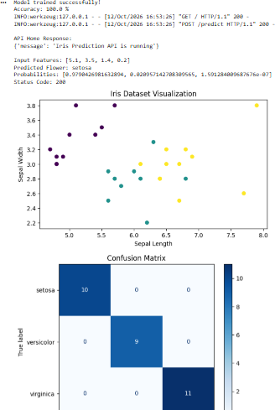
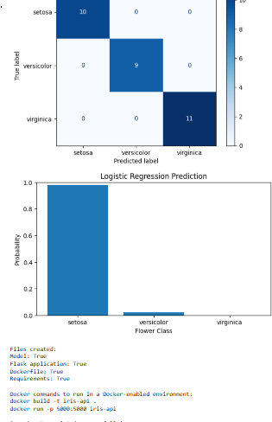

Result
The Random Forest machine learning model was trained and saved successfully. The Flask REST API was tested and returned predictions in JSON format. Graphs and a confusion matrix were displayed, and the Dockerfile and requirements file were created for containerization.

